Here are collected some bugs that I found on sites such as <https://www.oracle.com>, <https://www.amazon.com/>

email: [ug171180bvv@gmail.com](mailto:ug171180bvv@gmail.com)

skype: ug171180bvv

| **[QA211008-75] “Take the survey” is not relevant on https://www.oracle.com/** Created: 09/May/22  Updated: 09/May/22 | |
| --- | --- |
| **Status:** | Open |
| **Project:** | Training project |
| **Components:** | None |
| **Affects versions:** | None |
| **Fix versions:** | None |

| **Type:** | Bug | **Priority:** | Minor |
| --- | --- | --- | --- |
| **Reporter:** | Vasyl Bihari | **Assignee:** | Yurij Chernogorcev |
| **Resolution:** | Unresolved | **Votes:** | 0 |
| **Labels:** | None | | |
| **Remaining Estimate:** | Not Specified | | |
| **Time Spent:** | Not Specified | | |
| **Original estimate:** | Not Specified | | |
| **Environment:** | Windows 10, Chrome Версія 101.0.4951.54 | | |

| **Attachments:** | Screenshot_1.png     Screenshot_2.png     Screenshot_3.png |
| --- | --- |
| **Sprint:** |  |

| **Description** |  |
| --- | --- |

| 1. Go to <https://www.oracle.com/> On slider to choose “Introducing Oracle CloudWorld” Next “Subscribes for updates” Next in Let us know what you’d like to see and learn at our new conference in this brief survey click on “Take the survey” We get a page with text “Survey Is Now Closed. Thank you for your interest; however, this survey is no longer available.”   Expected result: after clicking on “Take the survey” we get a survey.  Actual result: : after clicking on “Take the survey” we get page with text “Survey Is Now Closed. Thank you for your interest; however, this survey is no longer available.”    It is necessary to remove the link on “Take the survey”. |
| --- |

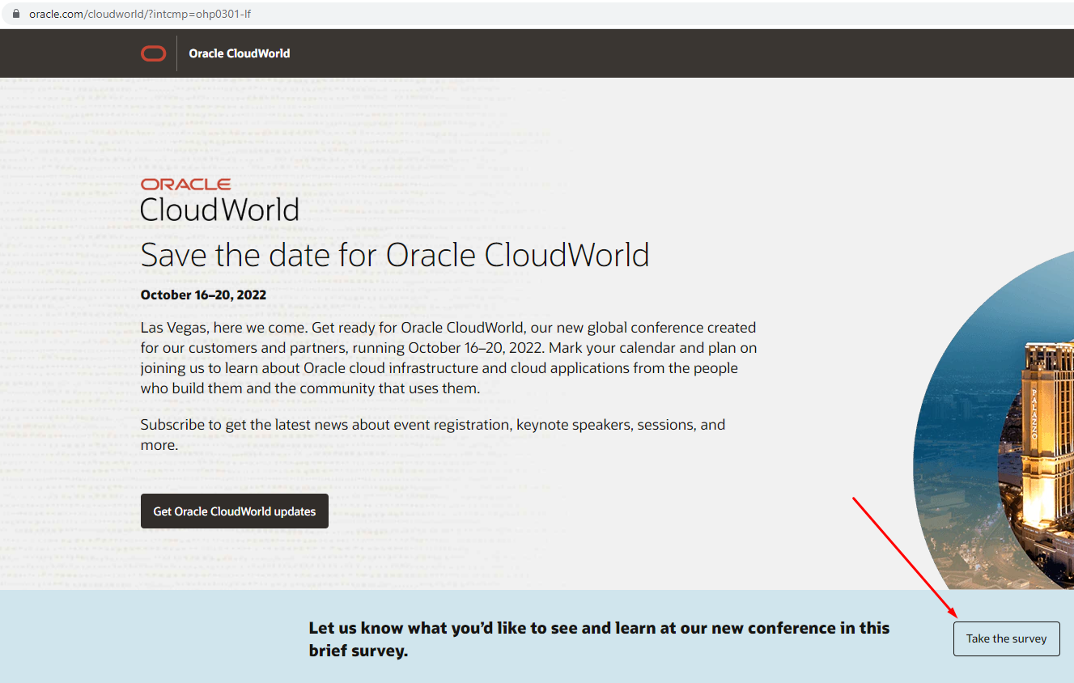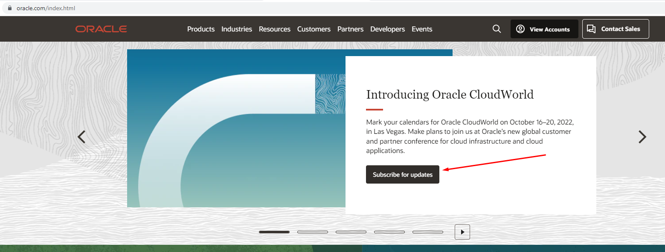

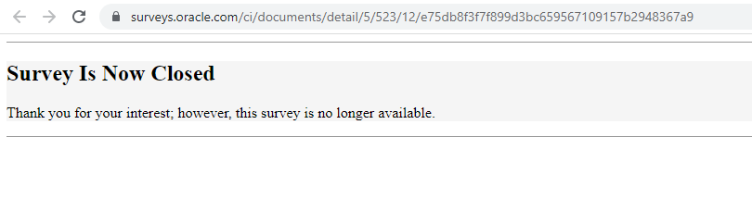Screenshot: Take the survey is not relevant.png

| **[QA211008-76] Error in the name of the product on Amazon** Created: 15/May/22  Updated: 15/May/22 | |
| --- | --- |
| **Status:** | Open |
| **Project:** | Training project |
| **Components:** | None |
| **Affects versions:** | None |
| **Fix versions:** | None |

| **Type:** | Bug | **Priority:** | Minor |
| --- | --- | --- | --- |
| **Reporter:** | Vasyl Bihari | **Assignee:** | Yurij Chernogorcev |
| **Resolution:** | Unresolved | **Votes:** | 0 |
| **Labels:** | amazon.com | | |
| **Remaining Estimate:** | Not Specified | | |
| **Time Spent:** | Not Specified | | |
| **Original estimate:** | Not Specified | | |
| **Environment:** | Windows 10 Pro; Chrome ver. 101.0.4951.54 | | |

| **Attachments:** | Screenshot_1.png |
| --- | --- |
| **Sprint:** |  |

| **Description** |  |
| --- | --- |

| 1. Go to <https://www.amazon.com> 2. Next on the slider choose "Shop Toys and Games" 3. Next in the filter "Featured Brands" choose brand "Pokemon" 4. In RESULTS on the page <https://www.amazon.com/s?bbn=16225015011&rh=n%3A16225015011%2Cp_89%3APokemon&dc&qid=1652603772&rnid=2528832011&ref=lp_16225015011_nr_p_89_0> we can see an error in the product name "Pokemn TCG: Collectors Bundle Spring 2022"   Expected Result: Product Name "Pokemon TCG: Collectors Bundle Spring 2022"  Actual Result: Product Name ""Pokemn TCG: Collectors Bundle Spring 2022"  Product name needs to be corrected |
| --- |

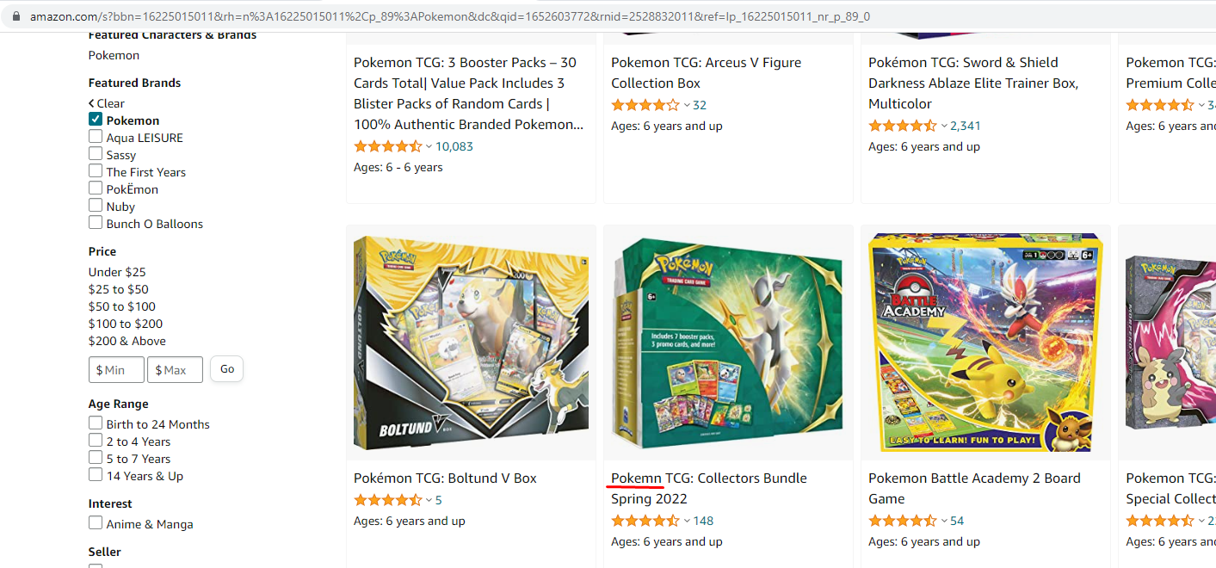

Screenshot: Error1.png

| **[QA211008-77] Error in product category on Amazon** Created: 15/May/22  Updated: 15/May/22 | |
| --- | --- |
| **Status:** | Open |
| **Project:** | Training project |
| **Components:** | None |
| **Affects versions:** | None |
| **Fix versions:** | None |

| **Type:** | Bug | **Priority:** | Major |
| --- | --- | --- | --- |
| **Reporter:** | Vasyl Bihari | **Assignee:** | Yurij Chernogorcev |
| **Resolution:** | Unresolved | **Votes:** | 0 |
| **Labels:** | amazon.com | | |
| **Remaining Estimate:** | Not Specified | | |
| **Time Spent:** | Not Specified | | |
| **Original estimate:** | Not Specified | | |
| **Environment:** | Windows 10 Pro; Chrome ver. 101.0.4951.54 | | |

| **Attachments:** | Screenshot_2.png     Screenshot_3.png |
| --- | --- |
| **Sprint:** |  |

| **Description** |  |
| --- | --- |

| 1. Go to <https://www.amazon.com> 2. On the slider choose "Shop Toys and Games" 3. Next in the filter "Age Range" choose "Birth to 24 Months" 4. In RESULTS we see the item "Mega Bloks First Builders Big Building Bag with Big Building Blocks, Building Toys for Toddlers (80 Pieces) - Blue Bag 3-5 years". 5. In the product name says "3-5 years", under the product name "Ages: 12 months - 5 years", and in the product description "Age Range (Description) - 1 years and up". 6. We see a discrepancy between the selected filter, age in the product name and in the product description.   Expected Result: "Mega Bloks First Builders Big Building Bag with Big Building Blocks, Building Toys for Toddlers (80 Pieces) - Blue Bag" must be in the 1 years and up category by the filter  Actual Result: Product is in category "Birth to 24 Months"  Need to move the product to the appropriate category. |
| --- |

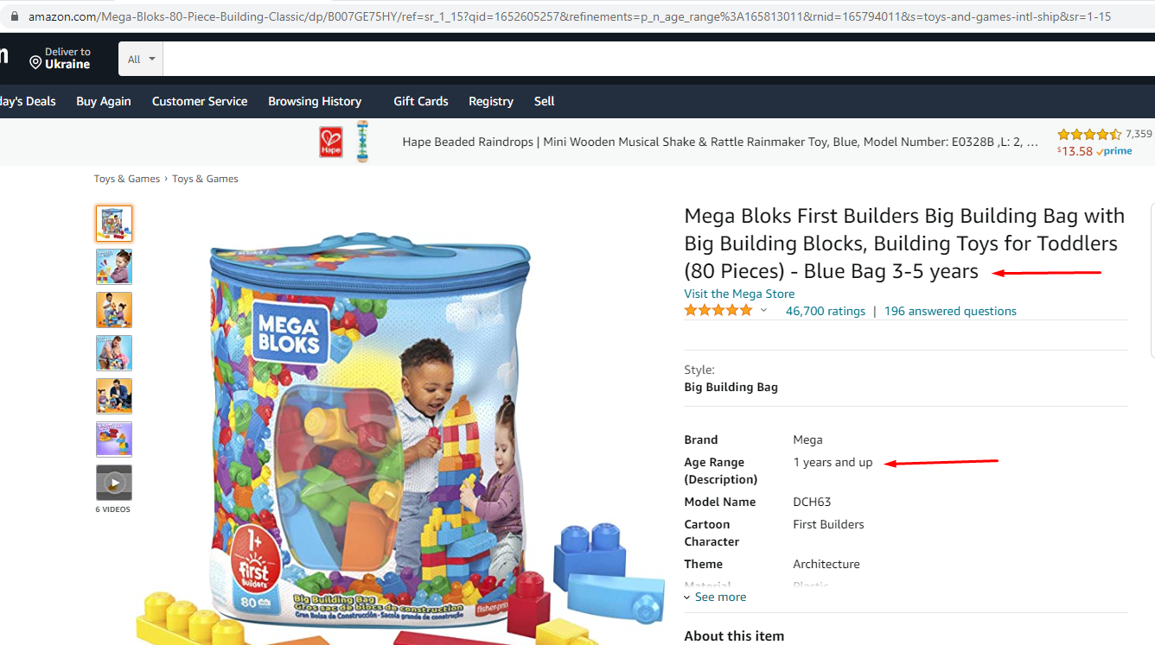

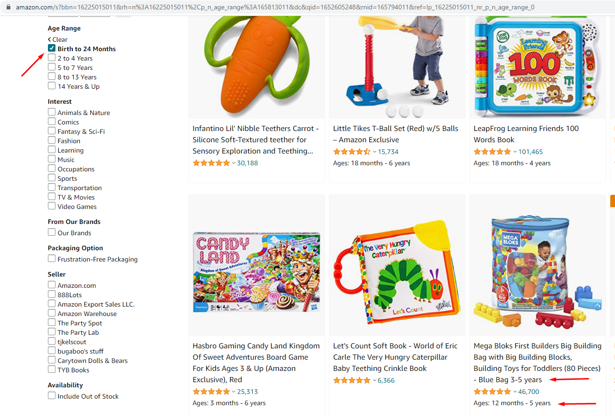

Screenshot: Error2.png

| **[QA211008-78] Error in the number of currencies on https://www.amazon.com/** Created: 15/May/22  Updated: 15/May/22 | |
| --- | --- |
| **Status:** | Open |
| **Project:** | Training project |
| **Components:** | None |
| **Affects versions:** | None |
| **Fix versions:** | None |

| **Type:** | Bug | **Priority:** | Minor |
| --- | --- | --- | --- |
| **Reporter:** | Vasyl Bihari | **Assignee:** | Yurij Chernogorcev |
| **Resolution:** | Unresolved | **Votes:** | 0 |
| **Labels:** | amazon.com | | |
| **Remaining Estimate:** | Not Specified | | |
| **Time Spent:** | Not Specified | | |
| **Original estimate:** | Not Specified | | |
| **Environment:** | Windows 10 Pro; Chrome ver.101.0.4951.54 | | |

| **Attachments:** | Screenshot_4.png |
| --- | --- |
| **Sprint:** |  |

| **Description** |  |
| --- | --- |

| 1.Go to <https://www.amazon.com/> 2. On the slider select "We hip over 45 million products around the world" 3. Next in the text "Shop in 75 currencies. Freedom to choose your preferred currency, click Select your currency 4. In "Currency Settings Select the currency you want to shop with" in the drop-down list of currencies, 67 currencies are charged 5. On the "[Amazon.com](http://amazon.com) ships worldwide" page says "Shop in 75 currencies"  Expected Result: The number of currencies on the "[Amazon.com](http://amazon.com) ships worldwide" page should match the drop-down list in "Select your currency" - "Currency Settings".  Actual result: "[Amazon.com](http://amazon.com) ships worldwide" page says "Shop in 75 currencies" and 67 currencies are charged in the drop down list of currencies.  Need to fix the number of currencies |
| --- |

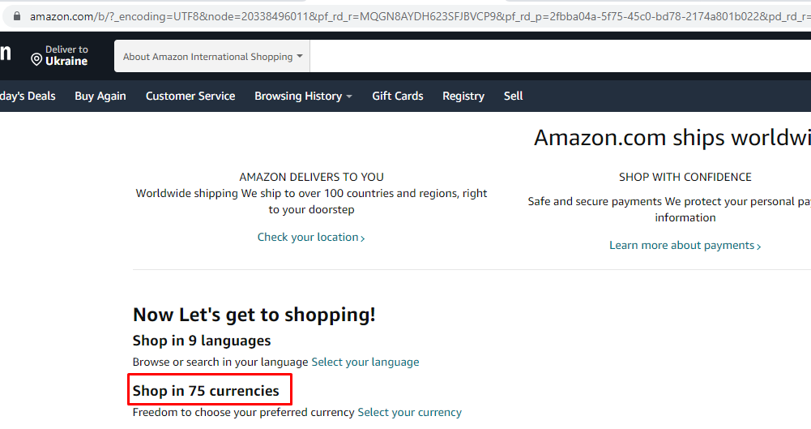

Screenshot: Error3.png

| **[QA211008-79] On amazon.com the product does not match the selected brand** Created: 15/May/22  Updated: 15/May/22 | |
| --- | --- |
| **Status:** | Open |
| **Project:** | Training project |
| **Components:** | None |
| **Affects versions:** | None |
| **Fix versions:** | None |

| **Type:** | Bug | **Priority:** | Major |
| --- | --- | --- | --- |
| **Reporter:** | Vasyl Bihari | **Assignee:** | Yurij Chernogorcev |
| **Resolution:** | Unresolved | **Votes:** | 0 |
| **Labels:** | amazon.com | | |
| **Remaining Estimate:** | Not Specified | | |
| **Time Spent:** | Not Specified | | |
| **Original estimate:** | Not Specified | | |
| **Environment:** | Windows 10 Pro; Chrome ver.101.0.4951.54 | | |

| **Attachments:** | Screenshot_6.png |
| --- | --- |
| **Sprint:** |  |

| **Description** |  |
| --- | --- |

| 1.Go to <https://www.amazon.com/> 2. Select "Computers & Accessories" 3. In the filter "Featured Brands" select the brand "HP" 4. On the 2nd (second) page of RESULTS the product "Samsung Electronics CLT-C504S Toner for CLP-415NW, CLX-4195FW, SL-C1810W, SL-C1860FW, Cyan (SU029A)" does not match the selected brand  Expected Result: In the filter "Featured Brands" in brand "HP" contains only HP brand products  Actual Result: In the filter "Featured Brands" in brand "HP" contains product of Samsung  Need to change the "Featured Brands" category for the product "Samsung Electronics CLT-C504S Toner for CLP-415NW, CLX-4195FW, SL-C1810W, SL-C1860FW, Cyan (SU029A)" |
| --- |

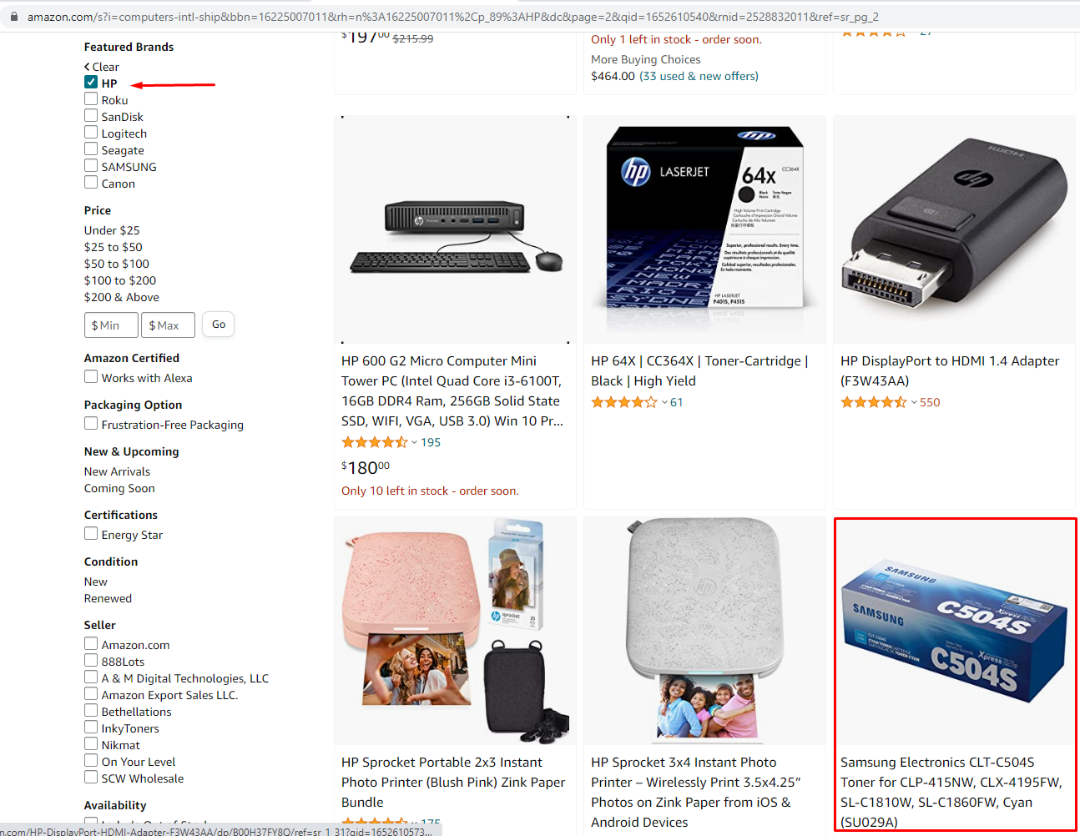

Screenshot: Error4.png